Company Logo: [https://fuel-roastery.myshopify.com/collections/tools/products/hario-glass-decanter-2cups](https://fuelsc.com/pages/about-us)

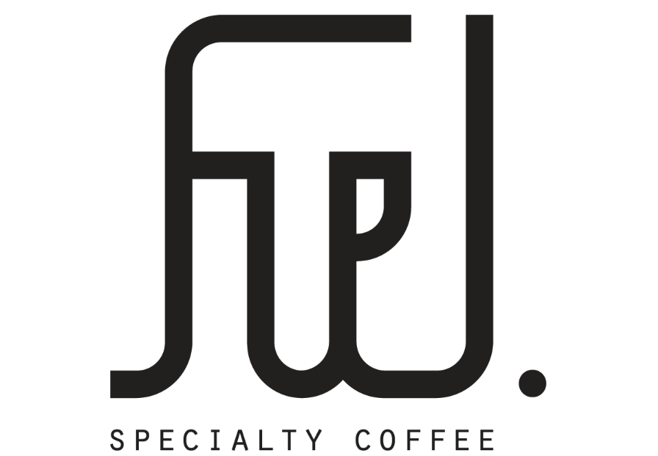

1. Product #1: <https://fuelsc.com/collections/coffee-beans/products/micro-carmo-espresso>

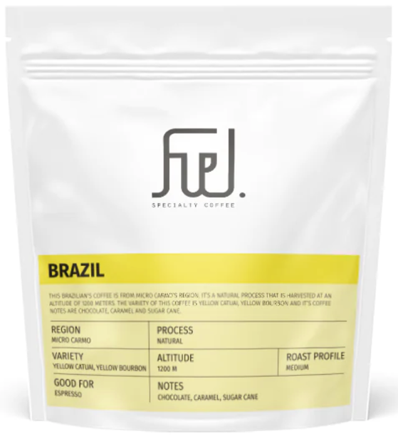

Product #2: <https://fuel-roastery.myshopify.com/collections/coffee-beans/products/addis-copy-filter>

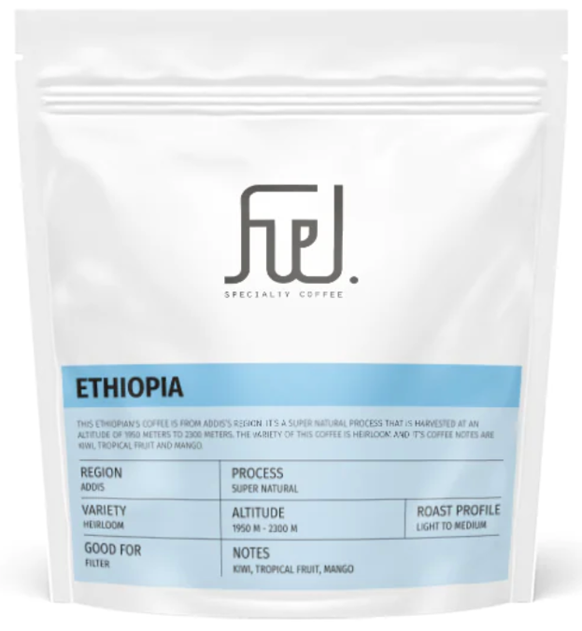

Product #3: <https://fuelsc.com/collections/coffee-beans/products/sweet-lakshana-a-filter>

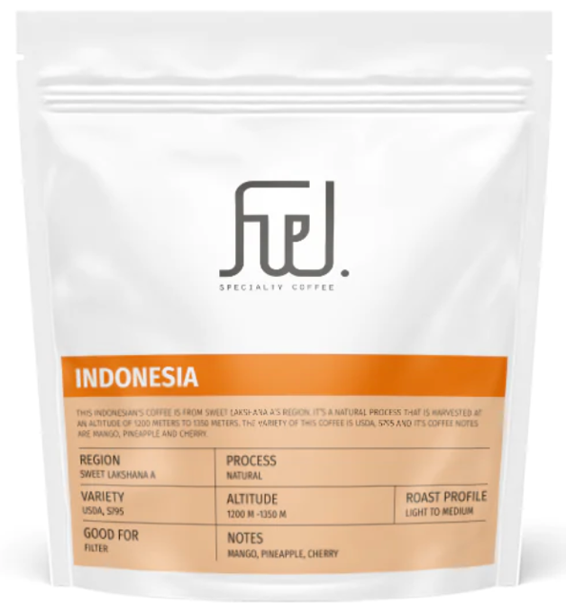

Product #4: <https://fuelsc.com/collections/coffee-beans/products/embu-mama-simba-aa-filter>

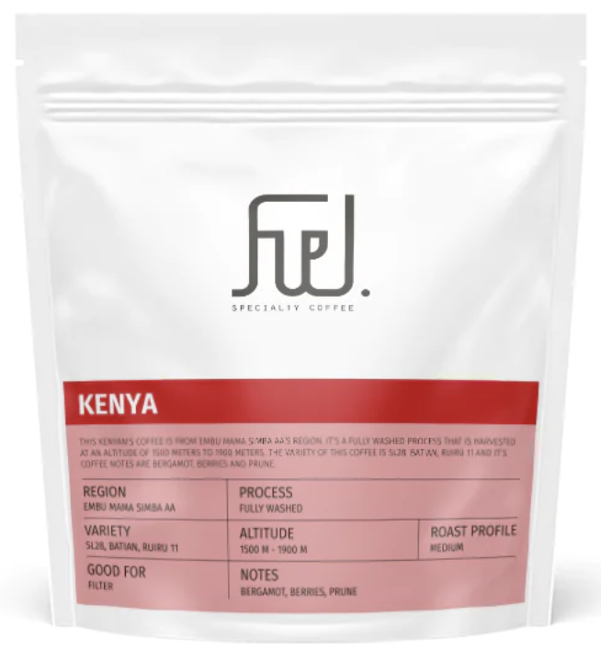

Product #5: <https://stories.starbucks.com/press/2022/starbucks-debuts-new-whole-bean-coffee-packaging/>

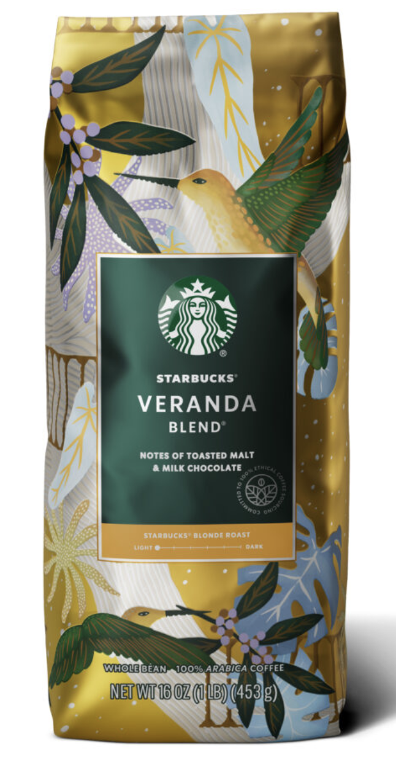

Product #6: <https://www.everything-coffee.co.uk/product/costa-coffees-mocha-italia-signature-blend/>

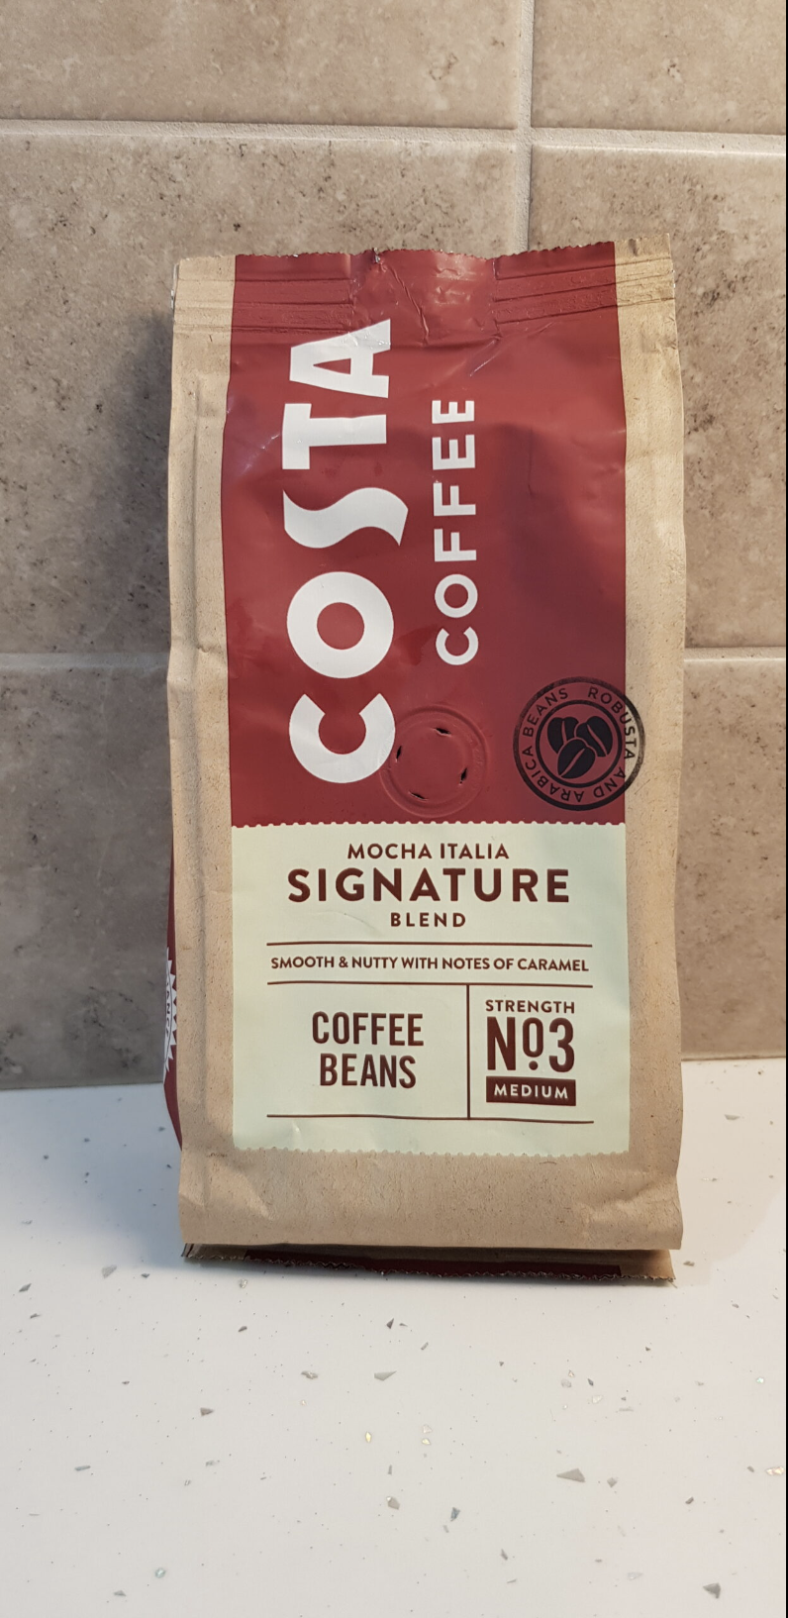

Product #7: <https://fuelsc.com/collections/all-products/products/kubwa-tano-aa-espresso>

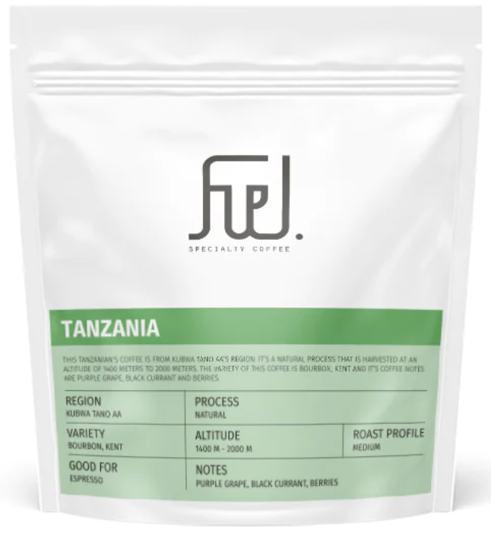

Product #8: <https://fuelsc.com/collections/all-products/products/matagalpa-filter>

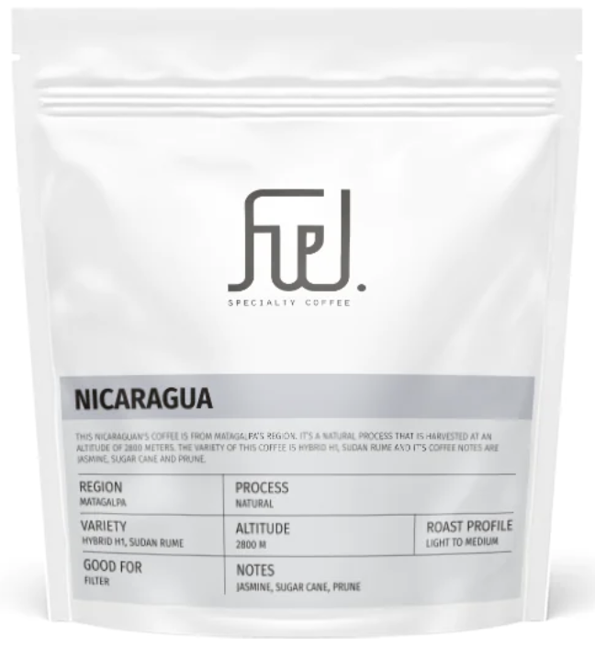

Product #9: [https://www.amazon.in/Nescafé-Intenso-Whole-Roasted-Coffee/dp/B08J3N5VXB](https://www.amazon.in/Nescaf%C3%A9-Intenso-Whole-Roasted-Coffee/dp/B08J3N5VXB)

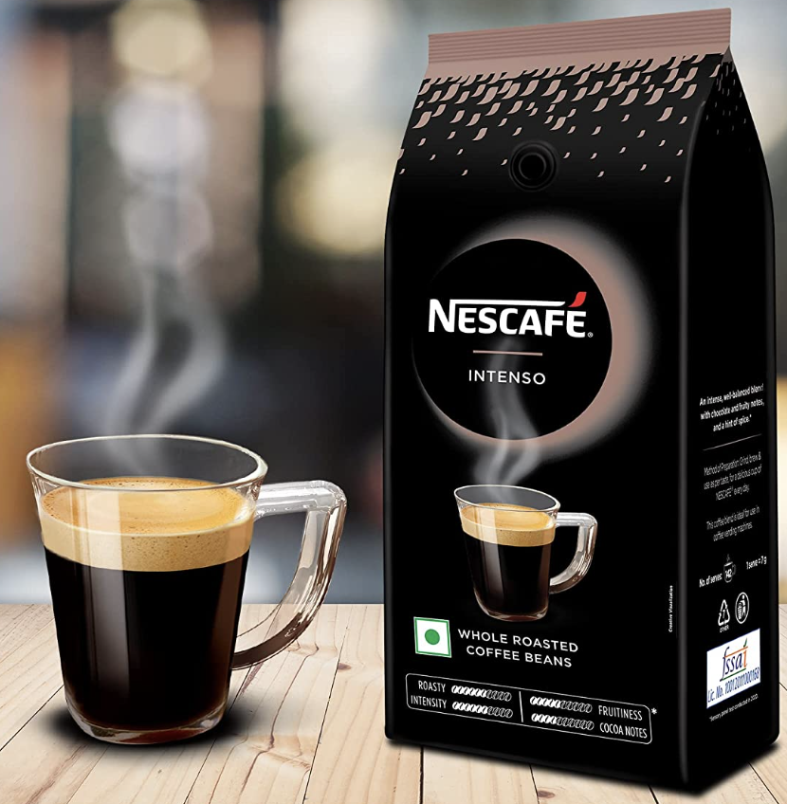

Product #10: <https://www.gosupps.com/tim-hortons-whole-bean-original-medium-roast-coffee-made-with-100-arabica-beans-32-ounce-bag-whole-bean-original-2-pound-pack-of-1.html>

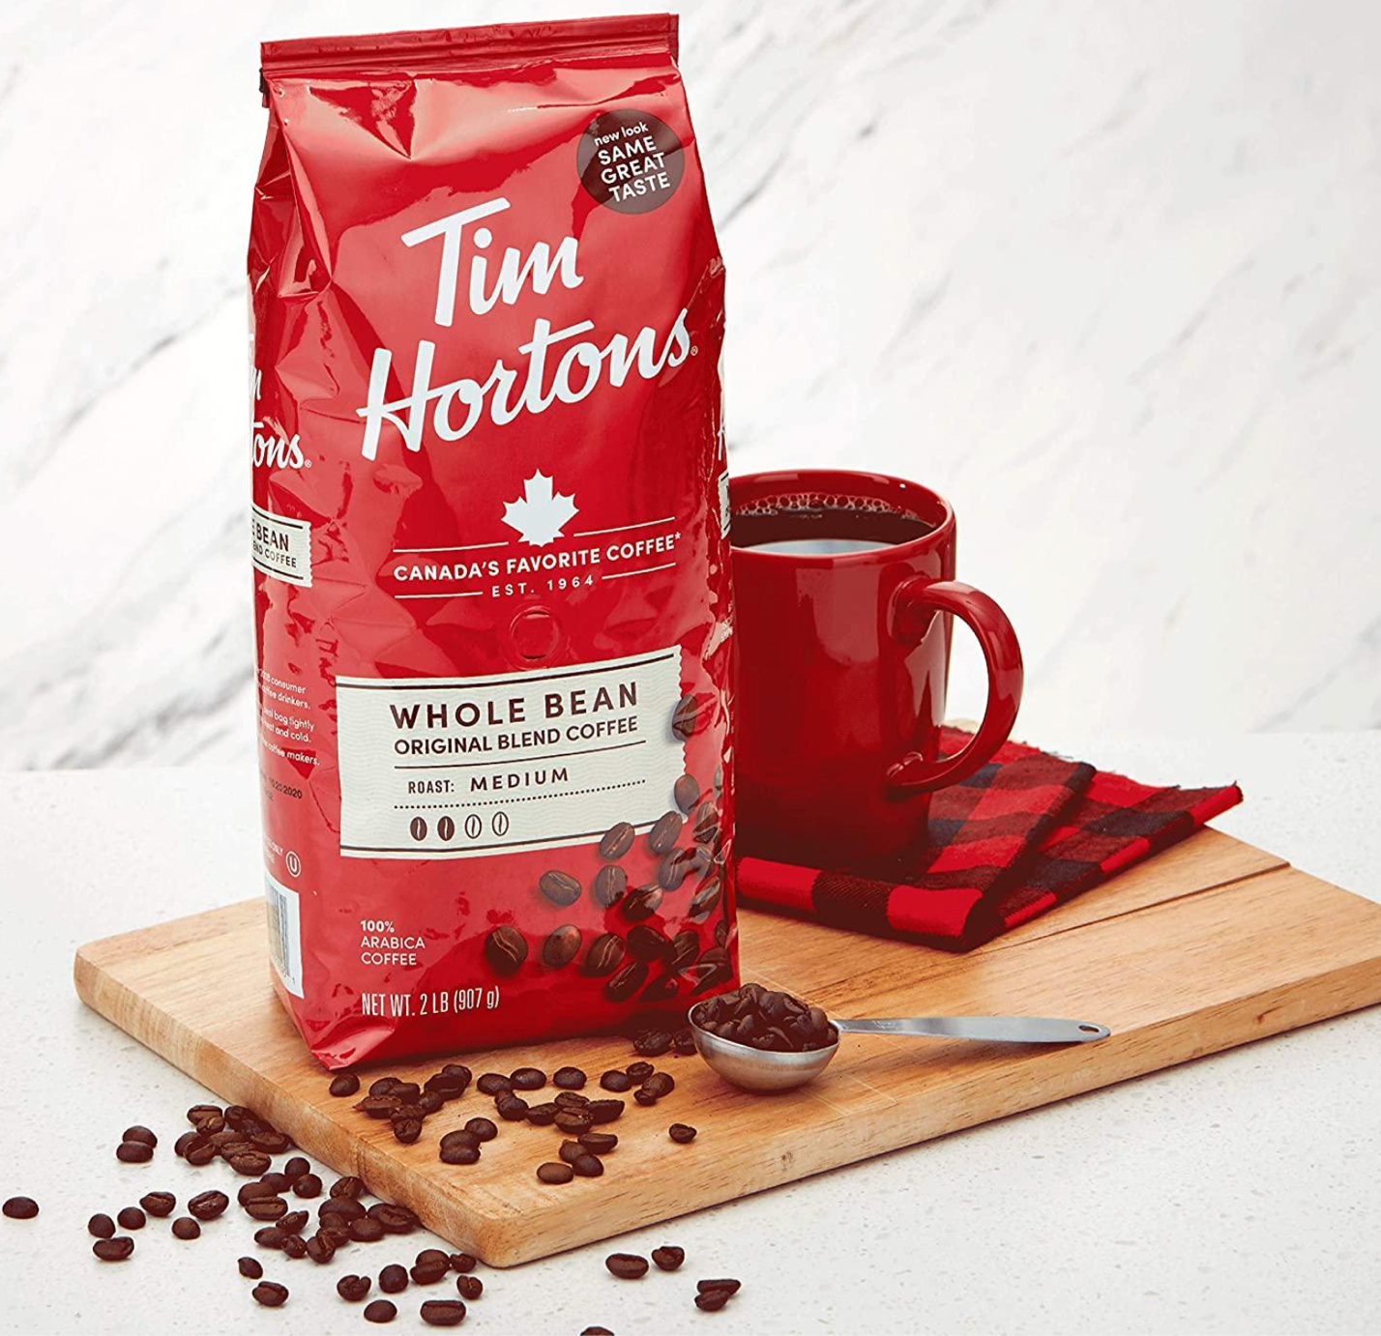

Product #11: <https://www.kaffekapslen.ie/classic-roast-coffee-beans-250-g-illy.html>

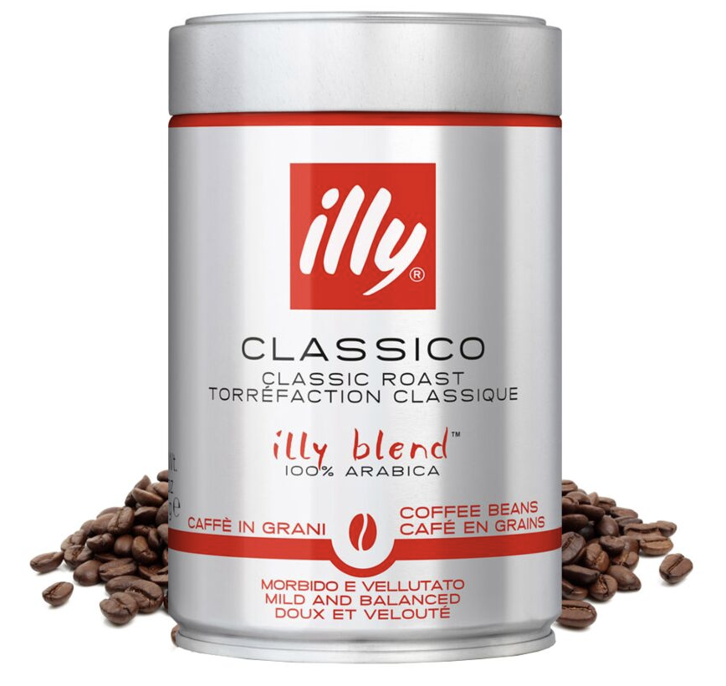

Product #12: <https://raya7balak.com/product/lavazza-qualita-rossa-beans-1kg/>

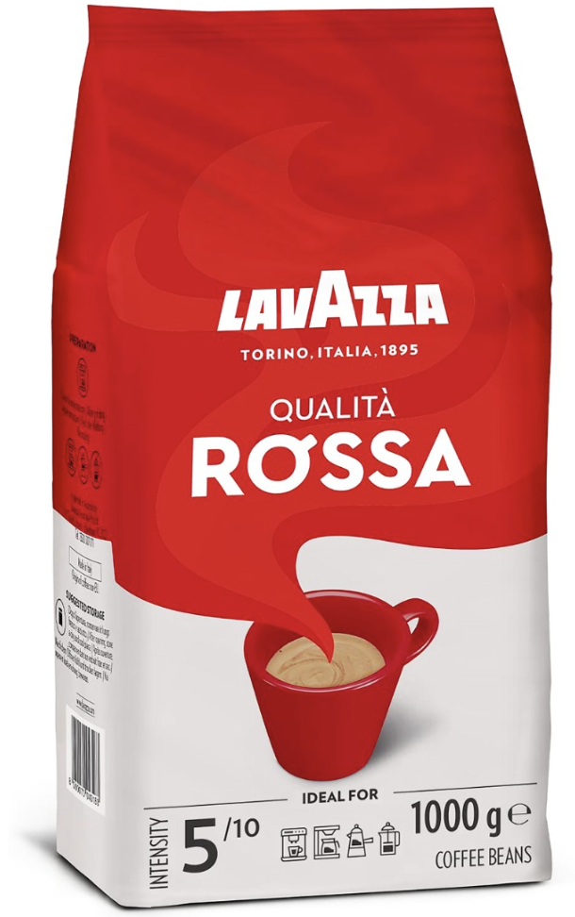

Product #13: <https://www.thecommonscafe.com/the-best-coffee-at-dunkin-donuts-a-blend-of-arabica-and-robusta-beans/>

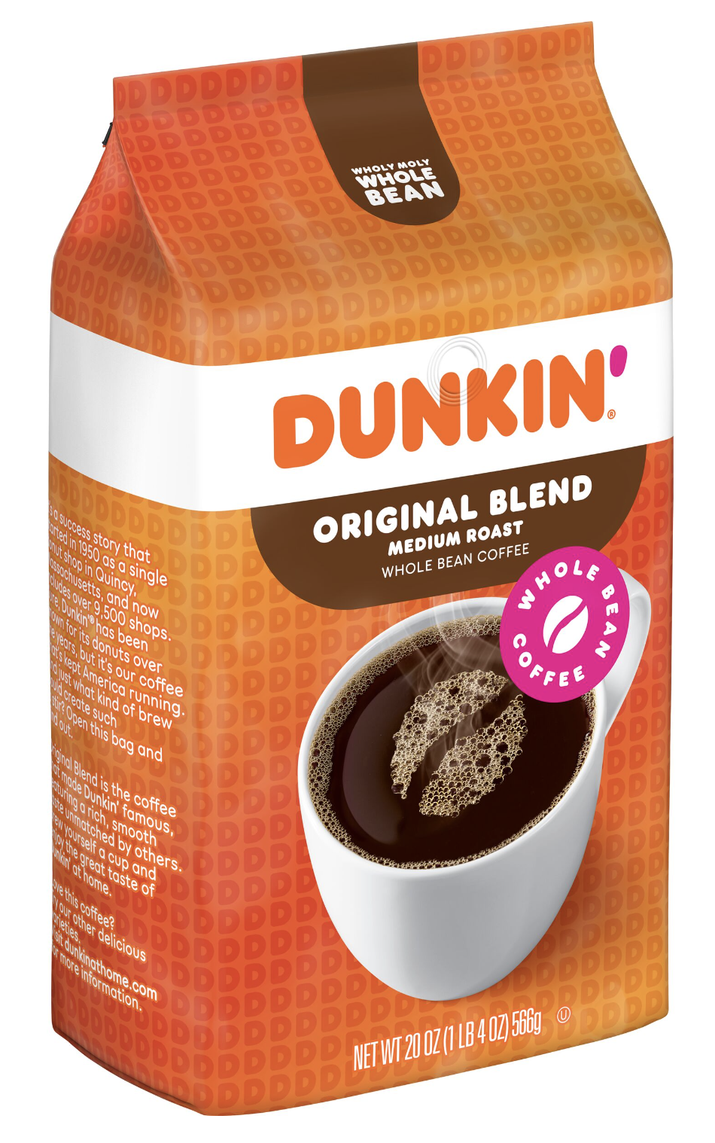

Product #14: [https://www.nepal.ubuy.com/en/product/1QHIGDRG-sumatra-mandheling-coffee-beans-medium-roast-whole-bean-fresh-roasted-16-ounce - gallery-1](https://www.nepal.ubuy.com/en/product/1QHIGDRG-sumatra-mandheling-coffee-beans-medium-roast-whole-bean-fresh-roasted-16-ounce#gallery-1)

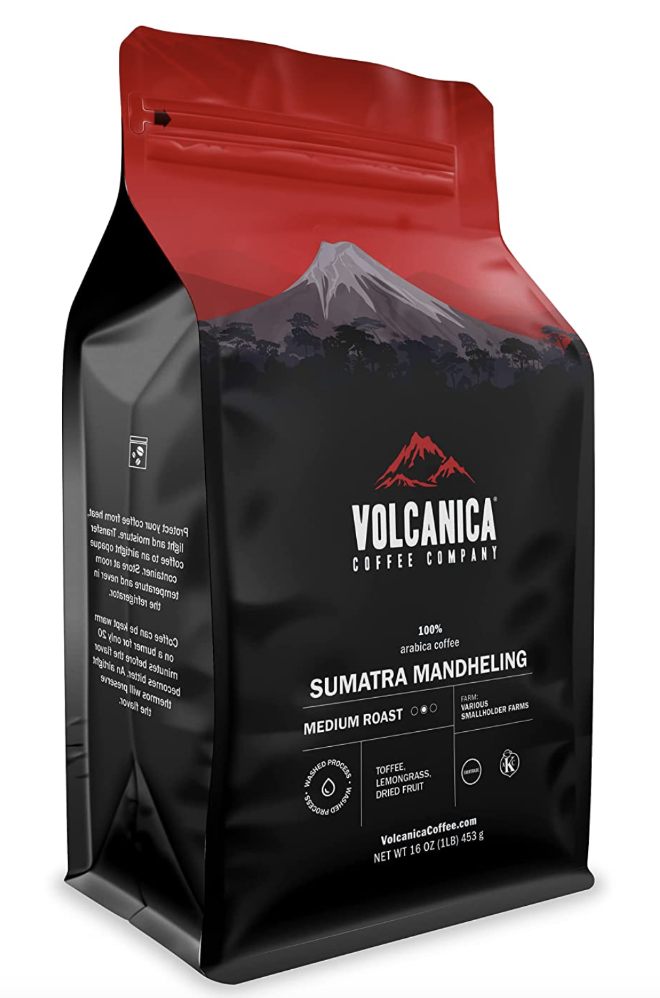

Product #15: <https://www.walmart.com/ip/Peet-s-Coffee-Tea-Bulk-Coffee-House-Blend-Whole-Bean-1-lb-Bag/37023423>

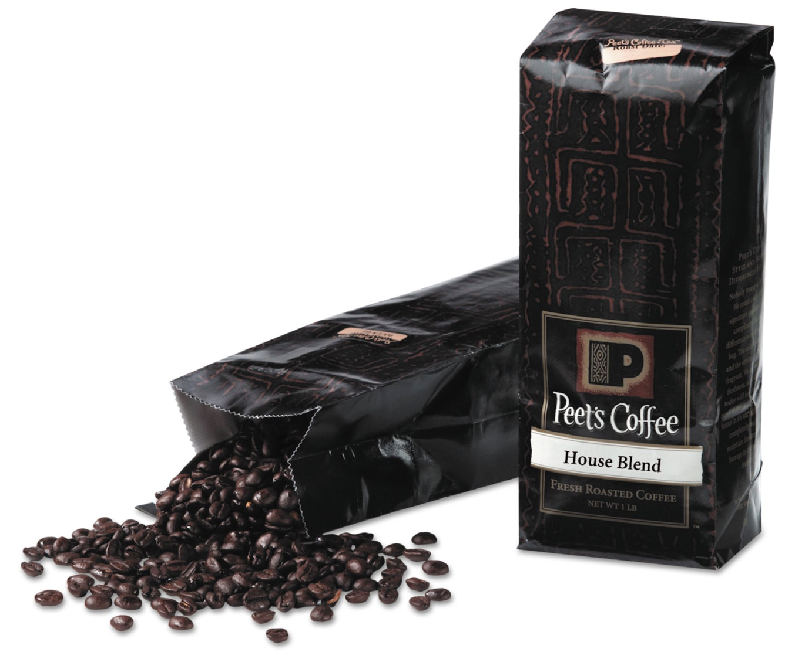

Social Media #1: <https://www.pngwing.com/en/free-png-abpub>



Social Media #2: <https://www.citypng.com/photo/9567/hd-old-facebook-instagram-square-logos-icons-png>



Coffee Beans: <https://www.instagram.com/p/CBaDcj0g8rT/>

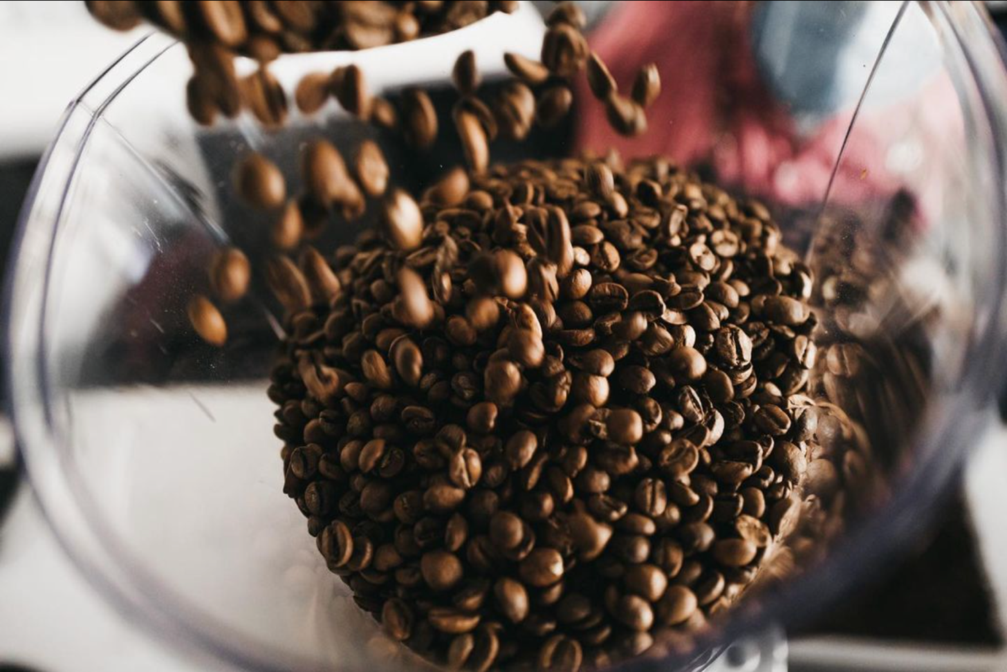

Coffee Field: <https://fuelsc.com/blogs/news>

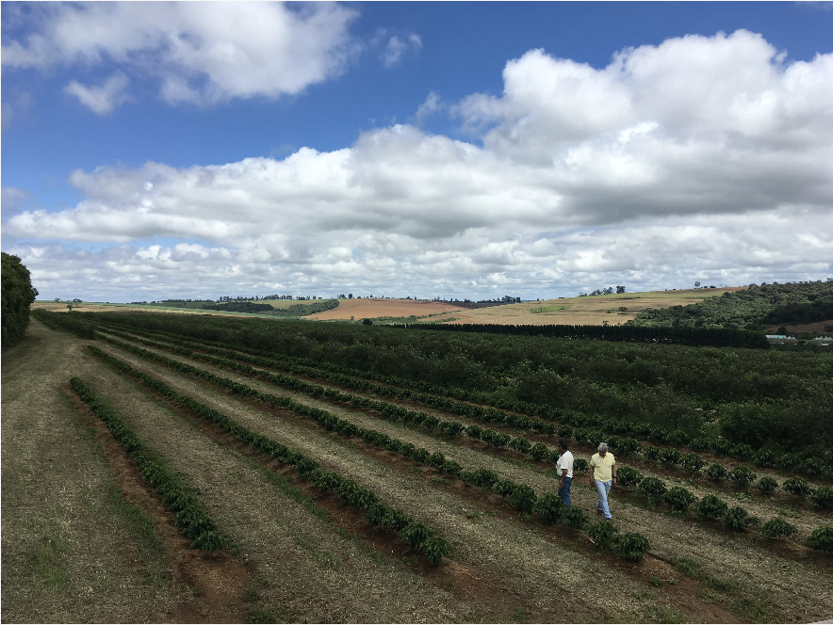

Delivery #1: <https://www.facebook.com/Talabatqa/?brand_redir=116079898419135>



Delivery #2:<https://play.google.com/store/apps/details?id=com.oryx.snoonu&hl=en_US&gl=US>



Coffee Beans #2: <https://www.wallpaperflare.com/toasted-coffee-beans-seeds-coffee-beans-wallpaper-mwteb>

